Assignment 5

Due to December 2, 2019

**Question 1**

‘Oring’ data set contains information on the first 24 space shuttle launches of the National Aeronautics and Space Administration’s Space Shuttle program. Information is recorded on six variables and the variable descriptions are as follows; An O-ring is a seal that separates the fuel supply from the combustible gases in the rocket’s exhaust; if it fails to do so perfectly, it will show signs of thermal distress after the launch. In cold weather, O-rings are less resilient and may be more likely to fail.

**VARIABLE DESCRIPTION**

FlightNumber: Number of space shuttle flight.

Temperature: temperature during start (in degrees F).

Pressure: pressure.

Fail (Response Variable): did any O-ring failures occur? (no, yes).

NFailures: how many (of six) 0-rings failed?.

Damage: damage index.

1. Using logistic regression, model the way in which the probability of an O-ring failure depends on temperature.
2. What is the problem when you fit the regression model (a straight line on the first plot)? Which pattern revealed in this data set (based on the line on the second plot)?

The regression fits the data is not good. It’s a negative linear pattern with an outlier.

1. What is the coefficient for Temp?

The coefficient for temperature is variable “damage”.

1. Compare the pattern of the logistic regression to the pattern of the logit model.

When after transformation the pattern will be better, and the line becomes moderate. The logit transformation transforms a line to a logistic curve. Logistic regression fits a logistic curve to set of data because dependent variable only takes the values 0 and 1.

1. Estimate the odds ratio for O-ring failure with a 10 degree decrease in the launch temperature.

The odds ratio for O-ring failure with a 10-degree decrease is 8.055471e-01.

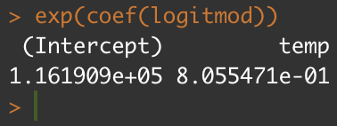

1. The 25th space shuttle launch, involving the space shuttle Challenger, took place on January 27, 1986. Seventy-three seconds into the flight, the fuel mixed with the rocket exhaust, resulting in an explosion which destroyed the shuttle and killed all seven astronauts on board. The launch temperature that day was 31 degrees. Based on data from the first 24 launches, estimate the probability of a O-ring failure on the Challenger flight.

The result of Challenger flight will have the similar result on the both results, they are 0.9930414 and 0.9896029.

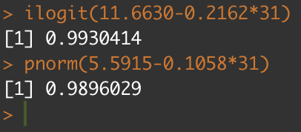

**Question 2**

Consider the ‘warpbreaks’ dataset, which is included with R. The dataset gives the results of an experiment to determine the effect of wool type (A or B) and tension (low, medium or high) on the number of warp breaks per loom. Data were collected for nine looms for each combination of settings.

As the response variable breaks is a count, it is best modeled as a Poisson distributed variable.

1. Using ‘glm’ function, build the Poisson model using the wool type and wool tension to predict the number of warp breaks (per loom) and interpret the coefficients in this context.

These 3 coefficients are all significant.

* For TensionM Exp (-0.32132) = 0.7241908; Average expected # of breaks w/ tensionM is about 2 times more than tension when the wool B held constant.
* For woolB Exp (-0.20599) = 0.8138425; for the every additional woolB unit on breaks, the # of breaks decrease by -0.20599.

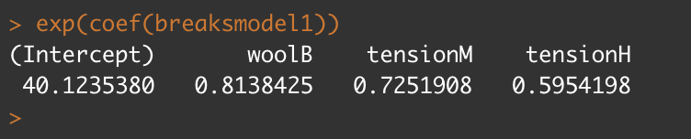

1. The model should have terms for the wool type, wool tension and the interaction between the two. Update the main effect model by adding interaction term and interpret the interaction effects.

For the interaction, woolB: tensionM is significant, we don’t consider woolB:tension.

1. Do you think the interaction term is helpful to improve the model? (Hint: See the ANOVA test).

No, Interaction is not helpful to improve the model.

